**Name:** Aliyan Ahmed Cheema

**Reg #** FA22-BCE-028

**Sequence Diagram:**

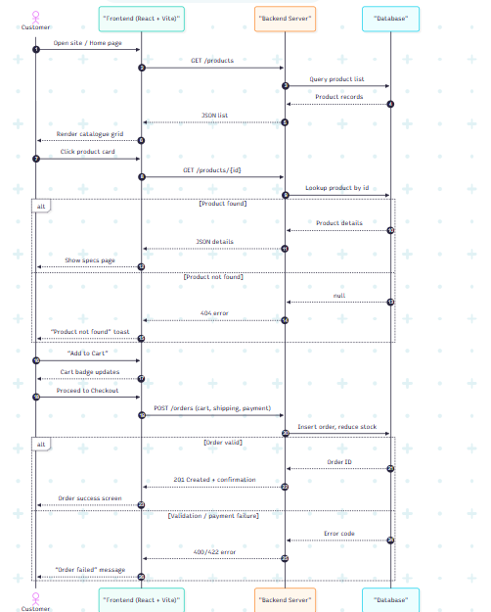

**Class Diagram:**

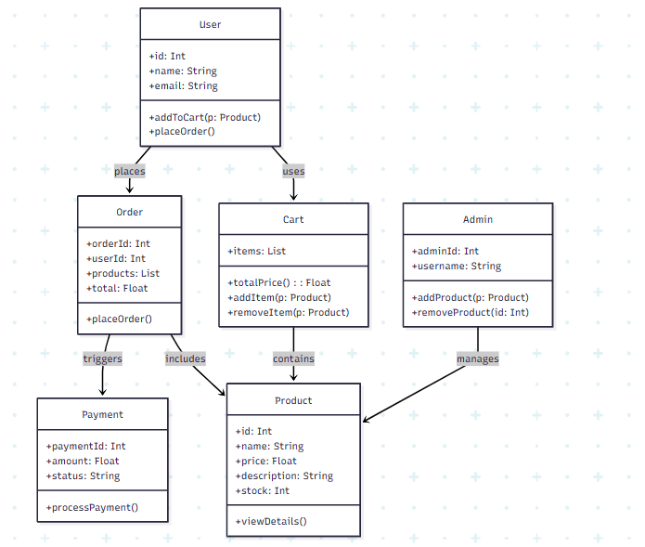

**Black Box Testing**

**🔹 1. Equivalence Class Partitioning (ECP)**

**🛒 *Use Case: Add Product to Cart***

| **Input Condition** | **Valid Class** | **Invalid Class** |
| --- | --- | --- |
| Product ID | Existing product | Non-existing product |
| Quantity | 1–10 | 0 or >10 |
| User authentication | Logged in | Not logged in |

**🧾 Example:**

* Add to cart(ProductID=3, Quantity=2) → ✅ Valid
* Add to cart(ProductID=100, Quantity=5) → ❌ Invalid product
* Add to cart(ProductID=1, Quantity=0) → ❌ Invalid quantity

**🔹 2. Boundary Value Analysis (BVA)**

**💳 *Use Case: Checkout Total Price Validation (0–99999 PKR)***

| **Test Case** | **Input Value (Total Price)** | **Expected Result** |
| --- | --- | --- |
| Min−1 | -1 | ❌ Reject (Invalid) |
| Minimum | 0 | ✅ Accept |
| Just Above Min | 1 | ✅ Accept |
| Mid Value | 50000 | ✅ Accept |
| Just Below Max | 99998 | ✅ Accept |
| Maximum | 99999 | ✅ Accept |
| Max+1 | 100000 | ❌ Reject (Invalid) |

**🔹 3. Decision Table**

**📦 *Use Case: Place Order***

| **Condition** | **C1** | **C2** | **C3** | **C4** |
| --- | --- | --- | --- | --- |
| User is logged in | Yes | No | Yes | Yes |
| Cart is not empty | Yes | Yes | No | Yes |
| Valid shipping & payment info | Yes | - | - | No |
| **Action: Allow Checkout** | Yes | No | No | No |

✅ = All conditions met  
❌ = One or more key conditions failed